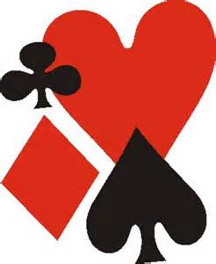 | JOHN WAKEN  PASADENA SECTIONAL
HOSTED BY
PASADENA BRIDGE CLUB
649 N Fair Oaks Ave #201
Pasadena CA 91103
(626) 247-4457

Location: https://pasadenabridgeclub.com/location

Enter below the Clock Tower | Plenty of Parking

Director in charge: John Coulombe
Tournament assistants: Paula Olivares, Morris Jones

Card fee $14 Cash and credit cards

Events:
Stratifications are based on the average of players’ masterpoints and may be adjusted at game time to optimize playing conditions.

- Saturday July 27  - 10:00 AM Open Pairs  - 10:00 AM 499er Pairs  - 3:00 PM Open Pairs  - 3:00PM 499 Pairs | - Sunday July 28  - 10:00 AM Open Pairs  - 10:00 AM 499er Pairs  - 3:00 PM Open Pairs  - 3:00PM 499 Pairs

Space is very limited! Make reservations early online using RSVPBridge. You can request to join the Open or 499er groups and select your events here:

https://www.rsvpbridge.com/join/PasadenaSectional2024 | 
So many great lunch options at the site!
Also, near all the great Old Town Pasadena hotels and restaurants

  Sanction No. 2407323 | Z E R O T O L E R A N C E O B S E R V E D  Tournament Chairs: Angela Peters and Sherry Hansen

