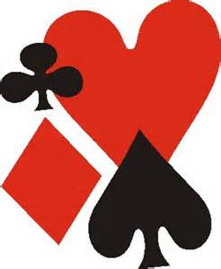 | JOHN WAKEN PASADENA SECTIONAL
HOSTED BY
PASADENA BRIDGE CLUB
649 N Fair Oaks Ave #201
Pasadena CA 91103
(626) 247-4457

Location: https://pasadenabridgeclub.com/location

Enter Below The Clock Tower
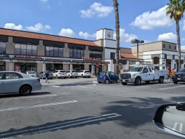
Plenty Of Parking
Director in Charge: John Coulombe

Tournament Assistants: Paula Olivares, Morris Jones

Card Fee $14 Cash And Credit Cards

Four Great Pairs Games Each For 499ers And Open Pairs. Single Session Events At 10:00 AM And 3:00 PM

Events:

Stratifications Are Based On The Average Of Players’ Masterpoints And May Be Adjusted At Game Time To Optimize Playing Conditions.

- Saturday July 27  - 10:00 AM Open Pairs  - 10:00 AM 499er Pairs  - 3:00 PM Open Pairs  - 3:00PM 499 Pairs | - Sunday July 28  - 10:00 AM Open Pairs  - 10:00 AM 499er Pairs  - 3:00 PM Open Pairs  - 3:00PM 499 Pairs

Space Is Very Limited! Make Reservations Early Online Using RSVPBridge. You Can Request To Join The Open Or 499er Groups And Select Your Events Here:

https://www.rsvpbridge.com/join/PasadenaSectional2024 | 
So Many Great Lunch Options At The Site!

- Blaze Pizza  - Starbucks | - Donuts & Burgers  - Chinese | - Vallarta Market: Mexican and Sushi  - Subway | - Hoot's Wings

Also, Near All The Great Old Town Pasadena Hotels And Restaurants.

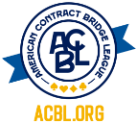  Sanction No. 2407323 | Z E R O T O L E R A N C E O B S E R V E D  Tournament Chairs: Angela Peters And Sherry Hansen

